Used Car Price Analysis

Abstract:
The automobile industry has witnessed a significant rise in the demand for used cars due to affordability, convenience, and wider availability of options. However, the pricing of used cars varies considerably depending on multiple factors such as brand, model, year of manufacture, mileage, fuel type, and location. This project, Used Cars Price Analysis, aims to analyze the price variations of used cars using data collected from reputed car-selling platforms through web scraping techniques.
The methodology involves data collection, cleaning, preprocessing, and applying statistical as well as visualization techniques to derive meaningful insights. Python libraries such as BeautifulSoup, Pandas, NumPy, and Matplotlib are used for data extraction, manipulation, and visualization, while Power BI dashboards provide interactive reporting and deeper analysis.
The analysis highlights trends in used car pricing across brands, fuel types, and years, enabling buyers to identify the best options with good quality at reasonable prices. Additionally, the project explores EMI calculations and company-wise comparisons to support better decision-making for customers.
The findings of this project provide a data-driven perspective on the used car market, helping buyers, sellers, and dealers understand key pricing determinants. Challenges such as data inconsistency, missing values, and rapidly changing market trends are also discussed. Overall, this project contributes to developing a structured approach for evaluating and comparing used cars, ensuring that customers make informed purchasing decisions.

Introduction:
In recent years, the used car market has emerged as one of the fastest-growing segments in the automobile industry. With increasing vehicle prices, rising fuel costs, and changing consumer preferences, many individuals are turning to used cars as a cost-effective alternative to buying new vehicles. The demand is also fuelled by the availability of certified pre-owned vehicles and the growth of online platforms such as Cars24, OLX Autos, and Spinny, which provide convenient ways to buy and sell cars.
However, one of the major challenges faced by consumers is price variation. The value of a used car is influenced by several factors, including the car’s brand, model, year of manufacture, mileage, fuel type, condition, and location. These factors make it difficult for buyers to estimate the fair price of a vehicle and often result in price mismatches across different platforms. Sellers, on the other hand, also face challenges in setting competitive yet profitable prices.
To address these challenges, this project titled “Used Cars Price Analysis” focuses on collecting real-time data from online car selling platforms and performing a comprehensive analysis of the pricing trends. The project employs web scraping techniques to gather relevant data, followed by data cleaning, pre-processing, and visualization using Python libraries and Power BI dashboards.
The main objectives of this project are:
- To identify how car prices vary across different brands and models.
- To analyze the influence of fuel type, mileage, and year of manufacture on pricing.
- To provide insights into company vs. price trends and EMI calculations.
- To assist customers in making data-driven decisions when buying or selling used cars.
By integrating data analytics techniques, this project not only provides valuable insights for buyers and sellers but also highlights the broader dynamics of the used car market. The findings will enable stakeholders to make informed choices, reduce pricing uncertainty, and maximize value.
Problem Statement:
The used car market is vast and dynamic, offering buyers a wide range of choices across brands, models, and conditions. However, one of the biggest challenges in this sector is the inconsistency in pricing. The same model of a car may be listed at different prices across multiple platforms, leaving customers uncertain about its fair value. Similarly, sellers often struggle to determine competitive yet profitable prices for their vehicles.
Several factors contribute to these inconsistencies, including:
- Car brand and model differences.
- Year of manufacture and mileage.
- Fuel type (petrol, diesel, electric, hybrid).
- Vehicle condition and ownership history.
- Geographic location and demand.
Without proper analysis, buyers risk overpaying, while sellers may undervalue their vehicles. Hence, there is a need for data-driven insights into used car prices to assist both buyers and sellers in making informed decisions.
Objectives:
The key objectives of the Used Cars Price Analysis project are:
- Data Collection: Gather real-world used car data from reputed online platforms using web scraping techniques.
- Data Cleaning & Pre-processing: Handle missing values, duplicates, and inconsistent formats to ensure reliable analysis.
- Exploratory Data Analysis (EDA): Examine car prices across brands, models, years, and other influencing factors.
- Visualization & Reporting: Build clear and interactive dashboards (using Python libraries and Power BI) to present insights.
- Decision Support: Provide customers with recommendations on the best value-for-money cars and help sellers set realistic prices.
- Challenges & Insights: Highlight challenges in data collection and present findings that reflect real market conditions.
Scope of the Project:
The scope of this project includes:
- Data Sources: Used car listings from online platforms such as Cars24, Spinny, OLX Autos, or similar marketplaces.
- Analysis Factors:
  - Brand-wise and model-wise price variations.
  - Influence of year of manufacture, mileage, and fuel type on pricing.
  - Company vs. price comparisons.
  - EMI calculations for affordability analysis.
- Tools & Technologies:
  - Python (BeautifulSoup/Selenium for web scraping, Pandas/Numpy for data manipulation, Matplotlib/Seaborn for visualization).
  - Power BI for dashboard creation.
- Deliverables:
  - Clean dataset of used cars.
  - Visualizations and dashboards showing insights.
  - Final report with findings, challenges, and conclusions.
Limitations:
- Data availability depends on website structure and restrictions.
- Market trends may change frequently, so results reflect only the timeframe of data collection.
Methodology:
The methodology for Used Cars Price Analysis is implemented in two phases: Data Collection (Web Scraping) and Data Cleaning & Manipulation, followed by Analysis & Visualization.
1. Data Collection (Web – Scraping)
The project uses Cardekho.com as the data source for scraping used car details. Python’s requests library is used to fetch HTML pages, and BeautifulSoup parses the data.
- Headers are defined with a User-Agent to mimic a real browser and prevent blocking.
- Each car listing page contains multiple car cards, which are iterated to extract details such as Title, Price, KM Driven, Fuel Type, Transmission, URL.
- For each car, the detail page is scraped separately to extract Owner type (First Owner, Second Owner, etc.) and EMI details.
- To speed up scraping, ThreadPoolExecutor is used for parallel requests.
- requests → Sending HTTP requests.
- BeautifulSoup → Parsing HTML content.
- re → Handling regex-based text extraction.
- ThreadPoolExecutor → Speeding up scraping by parallel processing.
Key Features Implemented:
- Price formatting function (format_price) – converts Lakh / Crore values into proper numeric ₹ values.
- Owner and EMI scraping function (scrape_owner_emi) – extracts owner type and EMI from detail pages.
- Pagination – loops over multiple listing pages to get more cars.
Code Snippet – Scraping Listing Pages
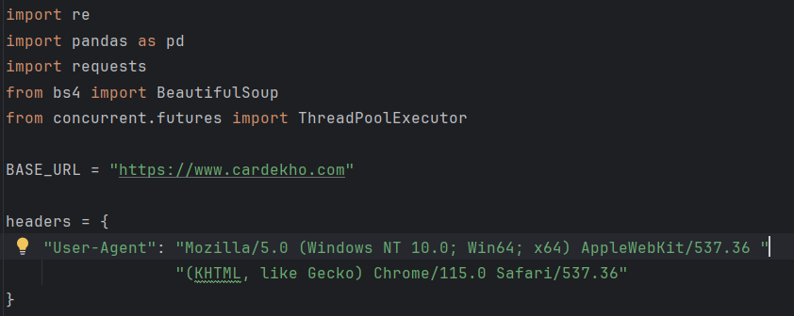
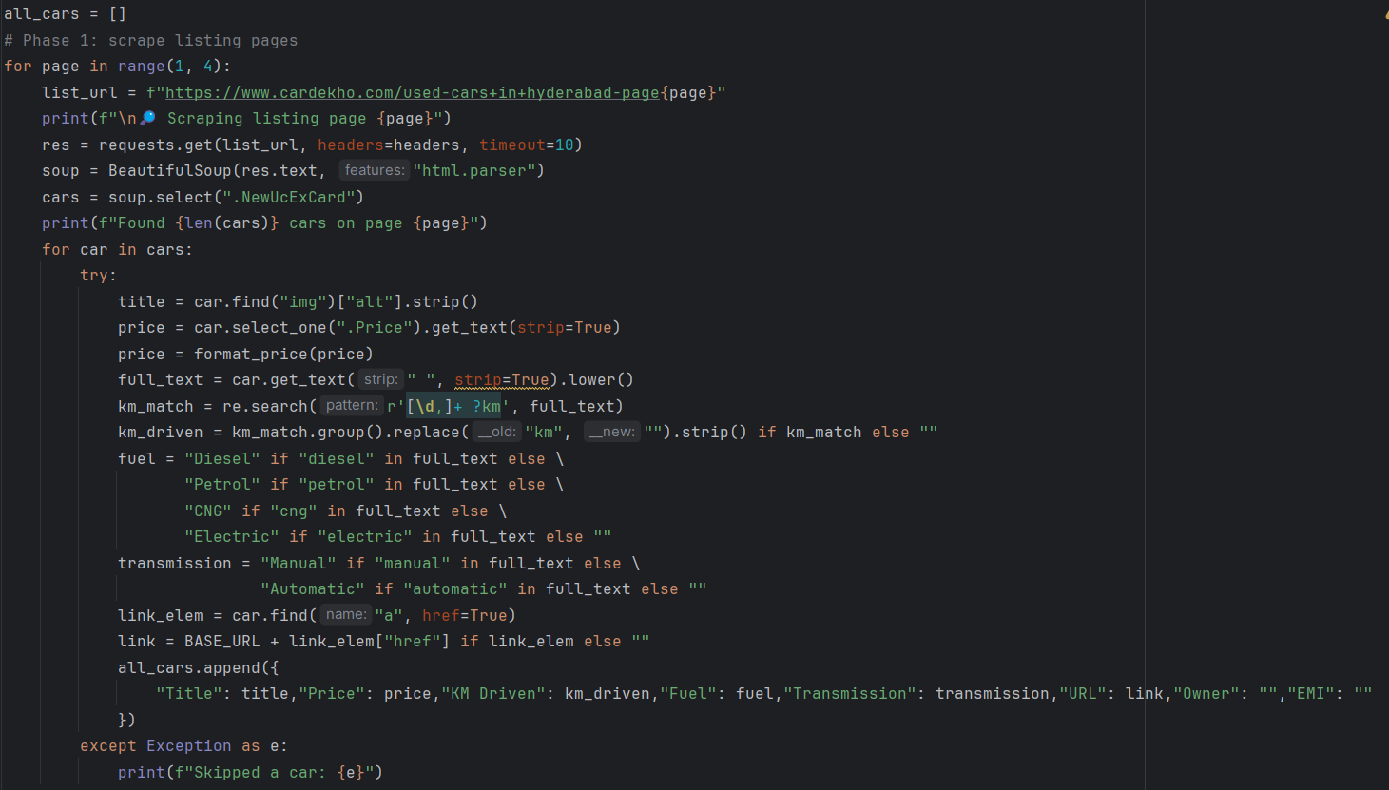Extracted details: Title, Price, KM Driven, Fuel Type, Transmission, URL
Code Snippet – Fetching Owner & EMI (Parallel)
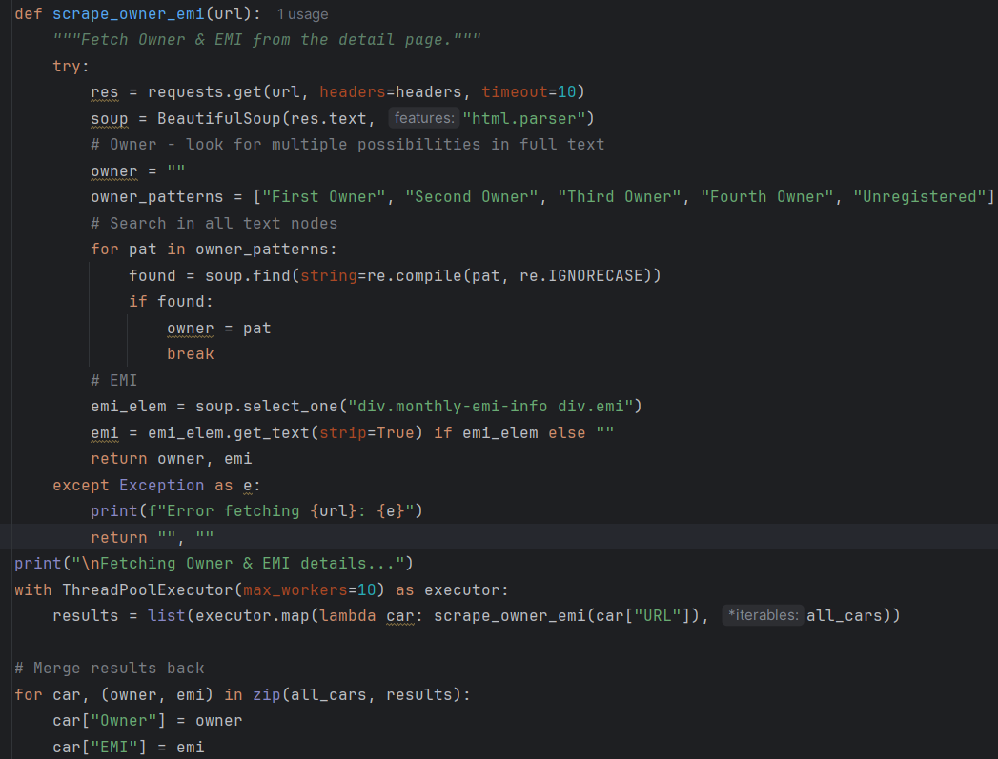
This improves performance by fetching Owner & EMI details concurrently.
2. Data Cleaning & Pre-Processing:
The raw scraped data contained missing values, inconsistent price formats, and unstructured text. Several cleaning steps were applied:
- Price Column: Converted from text (₹, commas, lakh/crore values) into numeric values.
- KM Driven: Extracted numbers from text (e.g., “45,000 km”) and converted into integers.
- EMI Column: Converted EMI text into numeric values.
- Categorical Columns (Fuel, Transmission, Owner): Standardized values with .title() and replaced missing/empty with "Unknown" or "nil".
- Missing Values:
  - Numeric columns → replaced with 0.
  - Text columns → replaced with "nil".
Additionally, a custom function extract_brand was applied on the Title column to extract the Brand Name (e.g., Hyundai, Kia, Tata, etc.).
- Convert Price to Numeric → remove ₹, commas, lakh/crore formatting.
- Convert KM Driven → extract numeric values.
- Standardize EMI → numeric monthly installment value.
- Handle Missing Values → fill empty with "nil" or 0.
- Standardize Categories → Fuel, Transmission, Owner.
Code Snippet – Cleaning Data
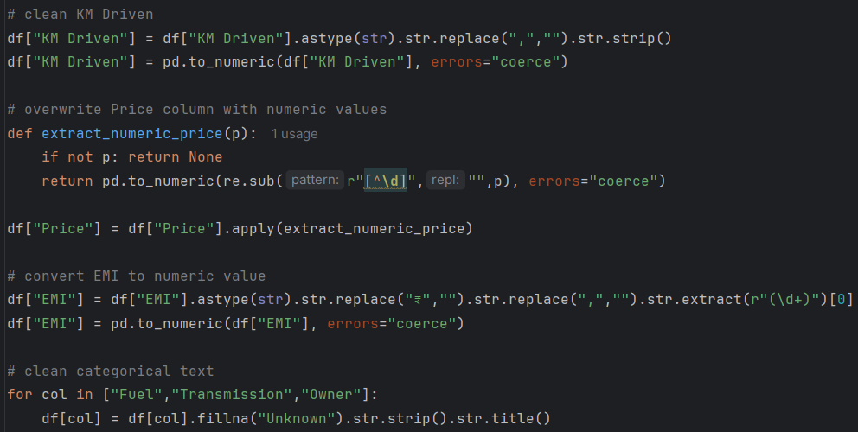
Ensures dataset is numeric-ready for analysis.
The cleaned dataset was saved into multiple CSV files for further analysis:
- cardekho_used_cars_fixed_final.csv – raw scraped data.
- cardekho_used_cars_cleaned.csv – cleaned dataset.
- cardekho_used_cars_cleaned_with_brand.csv – final dataset with Brand column.

3. Data Manipulation & Insights Generation:
Once cleaned, insights were generated using grouping, filtering, and aggregation.
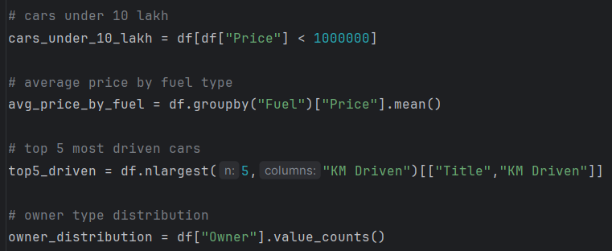
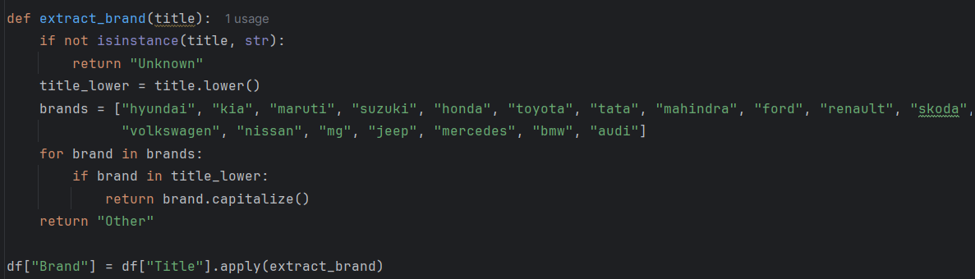
Now the dataset supports brand-level analysis.
4. Data Visualization & Analysis:
After cleaning and pre-processing, the dataset was imported into Power BI and also analysed in Python using Matplotlib for generating static charts.
- Visualization Using Python (Matplotlib)
1. Clustered Column Chart – Average Price by Fuel
Explanation:
This chart shows the average resale price of cars grouped by fuel type. It helps identify which fuel categories (Petrol, Diesel, CNG, Electric) hold higher value in the used car market.

Python Code:
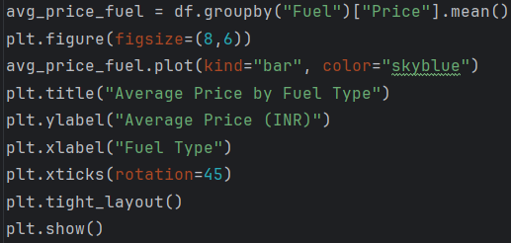
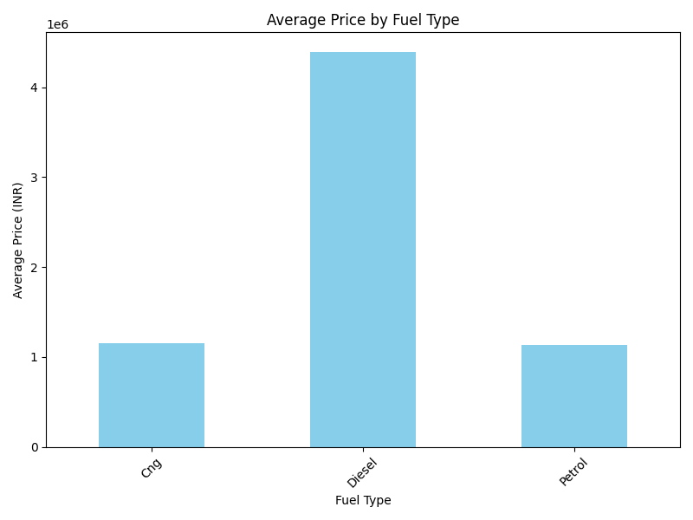
Insight:
  - Diesel cars tend to show higher average prices due to mileage efficiency.
  - Petrol cars dominate availability but have lower average resale price.
2. Scatter Chart – Price Vs KM Driven
Explanation:
A scatter plot between Price and KM Driven shows how mileage affects resale value. Cars with lower kilometres usually fetch higher prices.

Python Code:
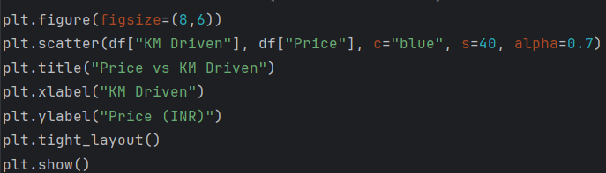
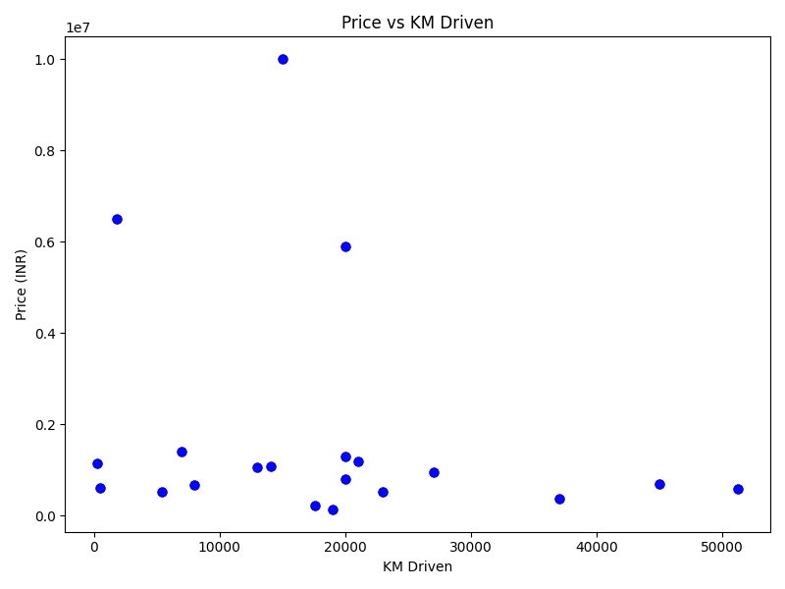
Insight:
  - Cars with >70,000 km driven show a significant drop in price.
  - Premium cars retain value better even after high usage.
3. Stacked Column Chart – Average Price by Brand
Explanation:
This chart shows the average resale price across different car brands. Brands with luxury models (BMW, Audi, Mercedes) stand out from mass-market brands (Maruti, Tata, Hyundai).

Python Code:
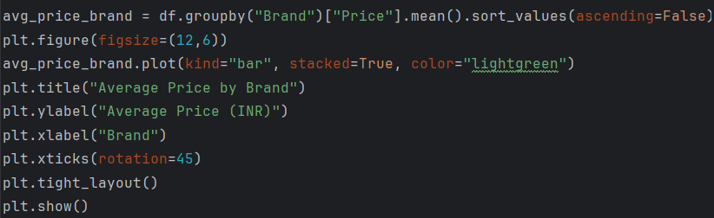
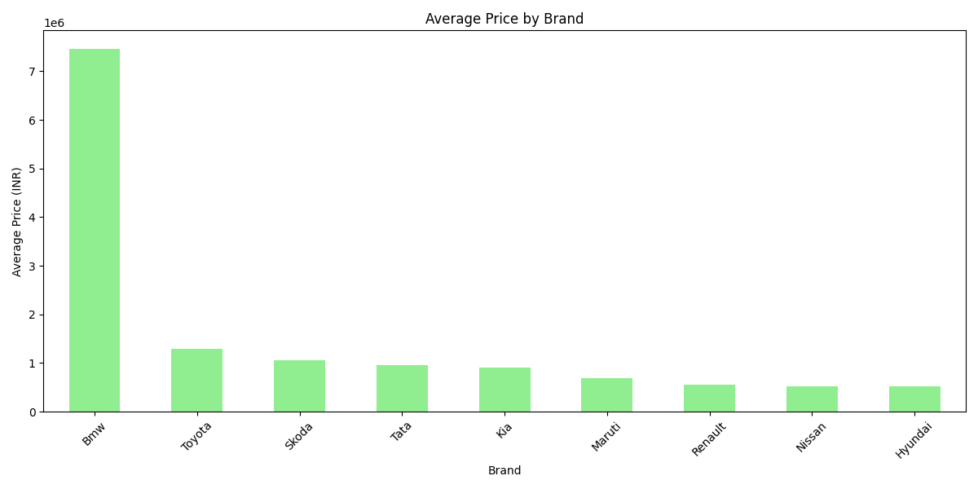
Insight:
  - BMW, Audi, Mercedes command the highest average resale prices.
  - Maruti, Hyundai, Tata dominate in terms of affordability and availability.

4. Donut Chart – Distribution of Cars by Owner Type
Explanation:
The donut chart highlights ownership history — whether cars are listed as First Owner, Second Owner, or Third Owner. Ownership is a key factor in buyer decisions.

Python Code:
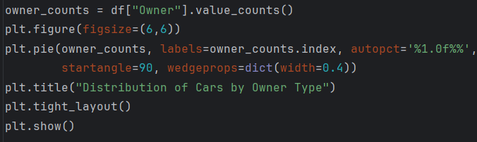
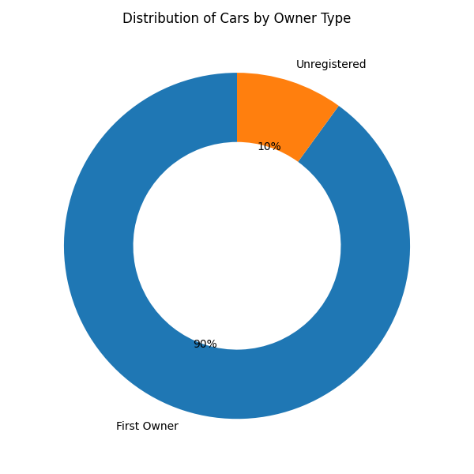
Insight:
  - Majority are First Owner cars, which are valued higher.
  - Second Owner cars are cheaper but less preferred by buyers.
5. Clustered Column Chart – Average Price by transmission
Explanation:
This chart compares the average resale value of cars by transmission type (Manual vs Automatic).

Python Code:
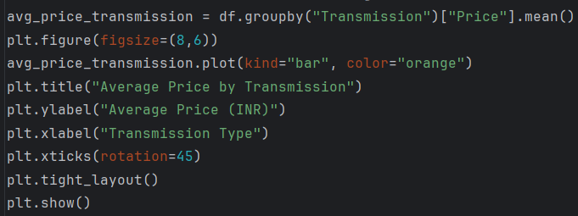
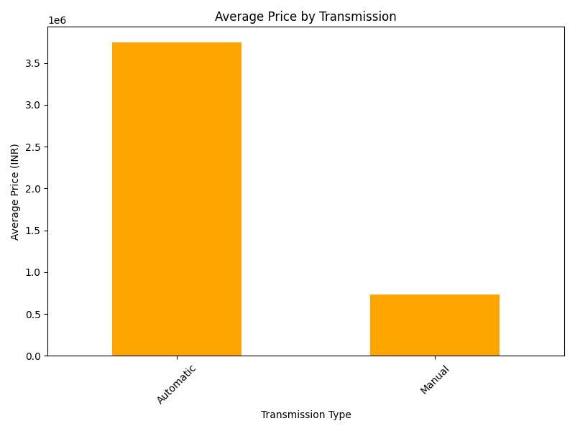
Insight:
Automatic cars tend to be priced higher than manual, reflecting their premium positioning in the market.
6. Clustered Bar Chart – Count of Title by Transmission:
Explanation:
A horizontal bar chart that shows how many cars in the dataset are Manual vs Automatic. This highlights availability trends.

Python Code:
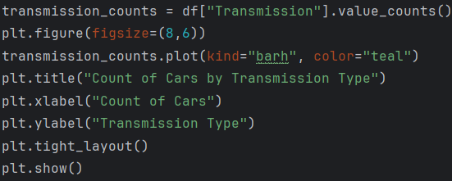
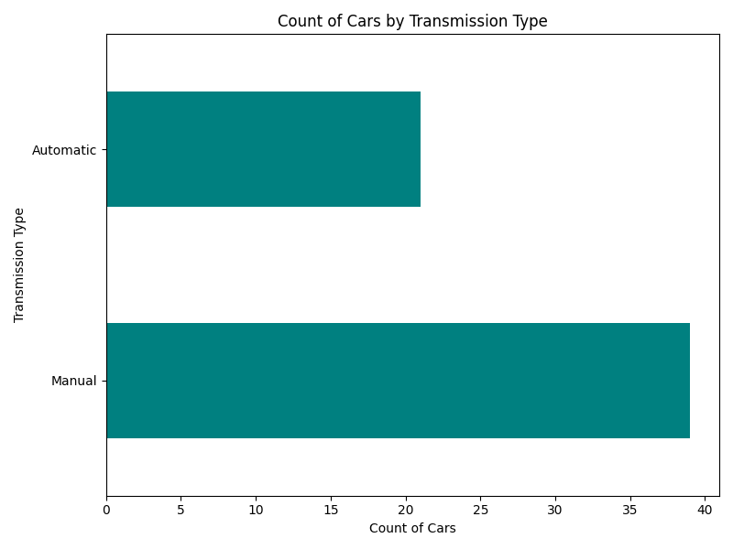
Insight:
  - Manual cars dominate availability in the used car market.
Automatic cars, though fewer, carry a premium resale price.

- Visualization Using Power BI
After cleaning the dataset with Python cardekho_used_cars_cleaned_with_brand.csv was imported into Power BI Desktop to create interactive dashboards.
1. Data Loading & Preparation:
      - Imported the cleaned dataset from CSV into Power BI.
      - Verified data types:
        - Price, KM Driven, EMI → Numeric.
        - Brand, Fuel, Transmission, Owner → Categorical.
      - Added calculated fields in DAX:
        - Measures: Total Cars, Avg Price, Avg KM Driven, Avg EMI.
2. Dashboard Pages:
Page 1: Overview Dashboard
      - KPIs (Cards):
          - Total Cars listed.
          - Average Price (₹).
          - Average KM Driven
          - Average EMI
      - Clustered Column Chart: Average Price by Transmission.
      - Donut Chart: Fuel Type Distribution (% of Petrol, Diesel, etc.).
      - Clustered Bar Chart: count of Title by Transmission
      - Slicers (Filters): Brand, Fuel, Transmission, Price Band.
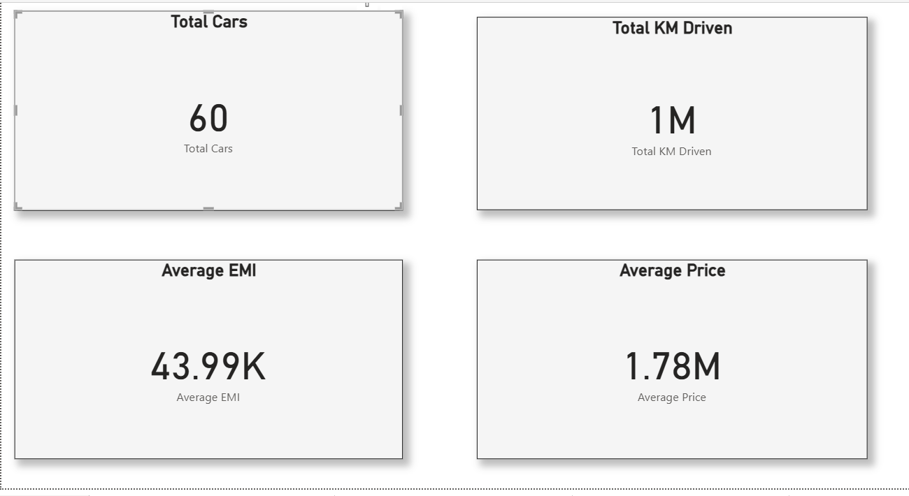
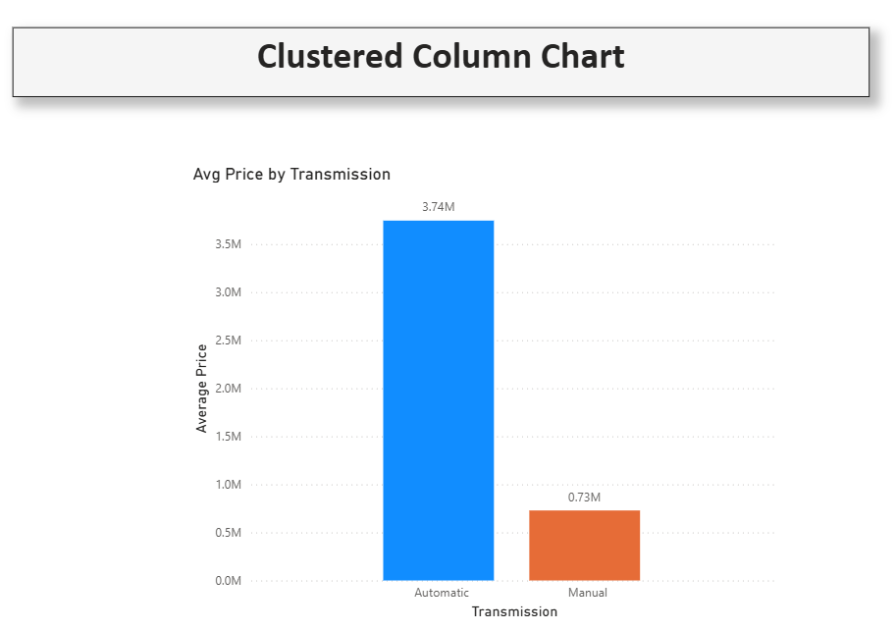
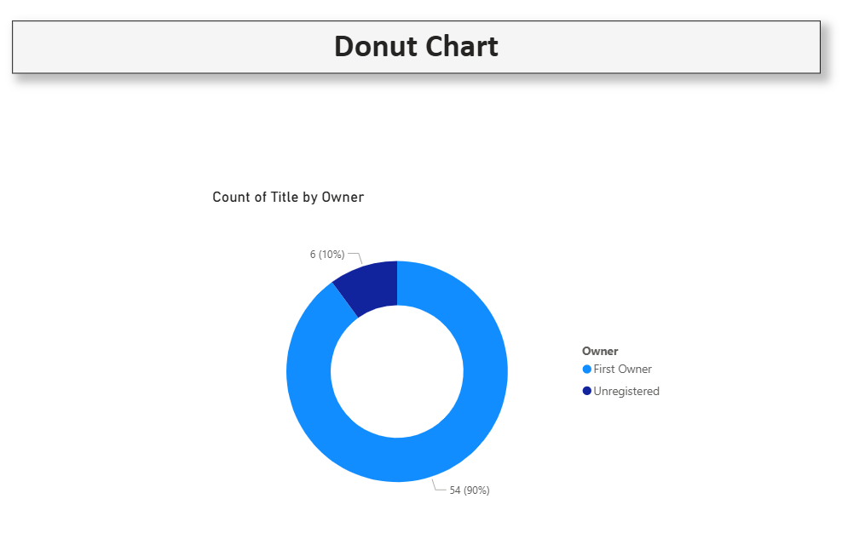
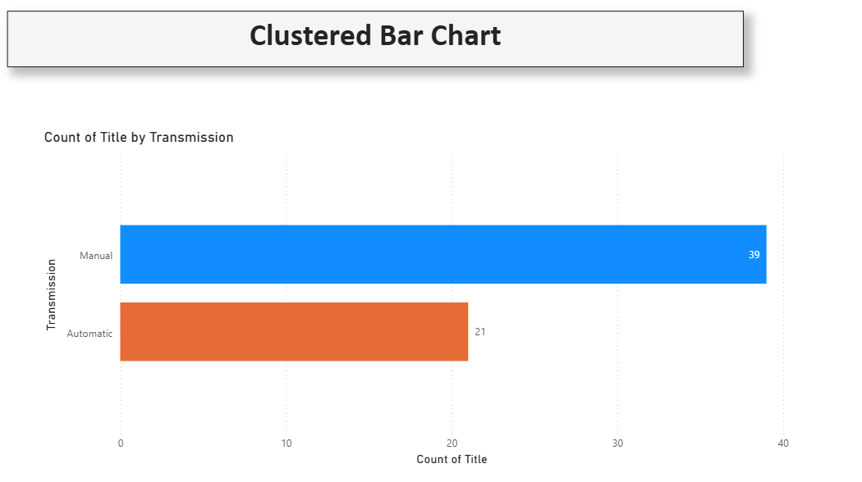
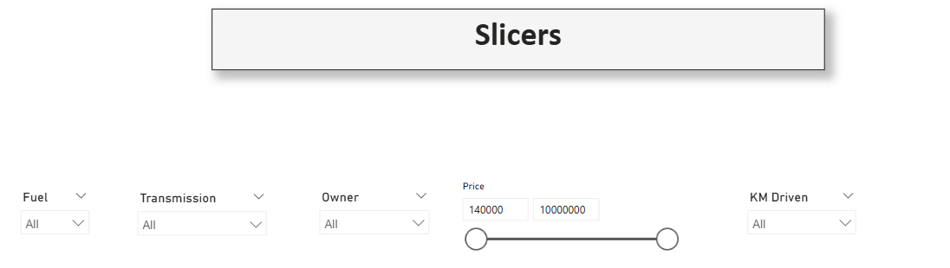
Insight:
Mass-market brands (Maruti, Hyundai, Tata) dominate in count, while luxury brands (BMW, Audi, Mercedes) dominate in price. Petrol cars are most common, but Diesel cars retain higher value.
Page 2: Affordability & EMI Dashboard
    - Stacked Column Chart: Cars distribution across Price Bands.
    - Scatter Plot: Price vs EMI (affordability check).
    - Table Visual: Title,Brand, Price, EMI side-by-side.
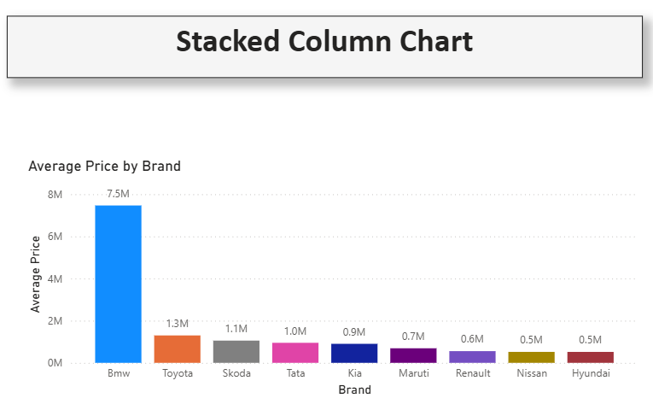
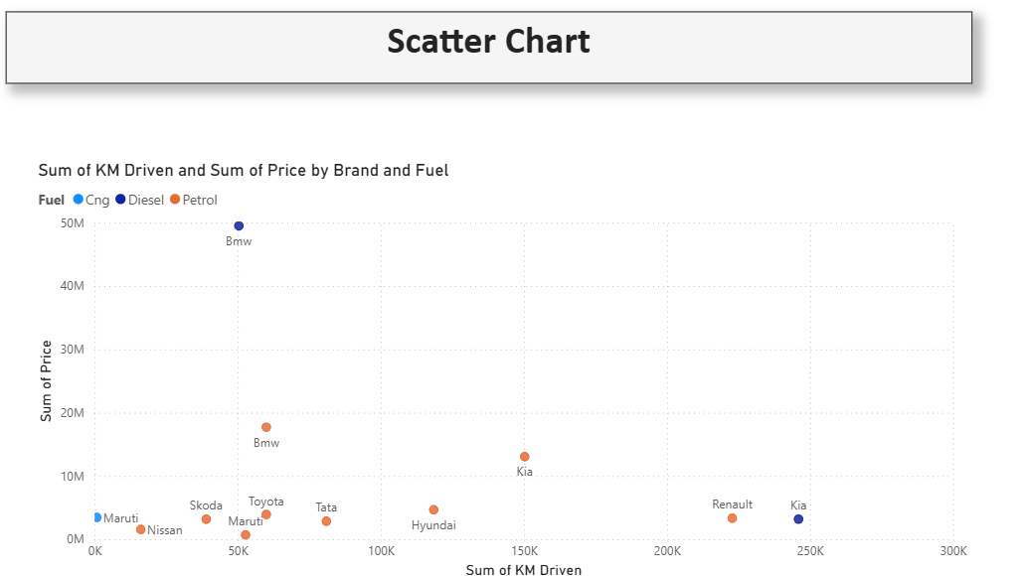
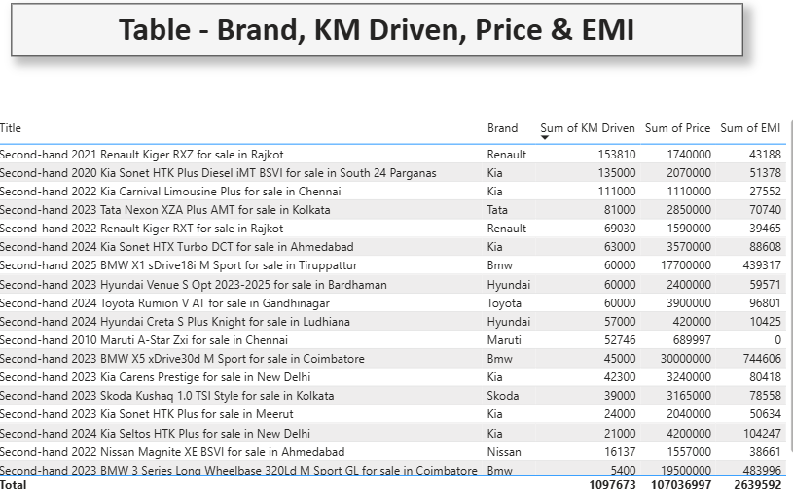

Insight:
Most cars fall under ₹10 Lakh, indicating affordability demand. Cars priced higher (>₹20 Lakh) are limited but have significant EMI values.

Page 3: Mileage Insight Dashboard
- Scatter Chart: KM Driven vs Price, color-coded by Fuel type.
- Table (Top-5 Most Driven Cars): Fixed ranking using RANKX measure to show cars with the highest mileage.
- Clustered Column Chart: Avg Price by Owner Type.
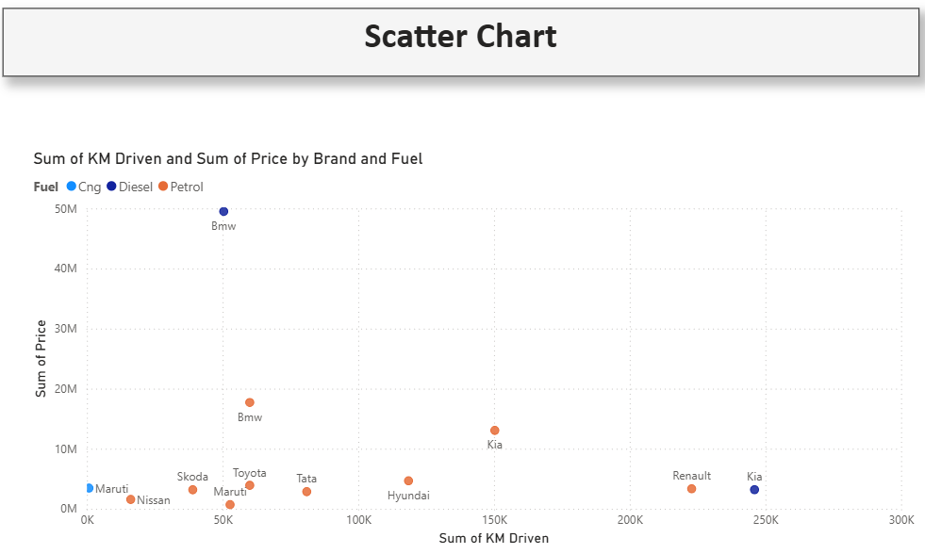
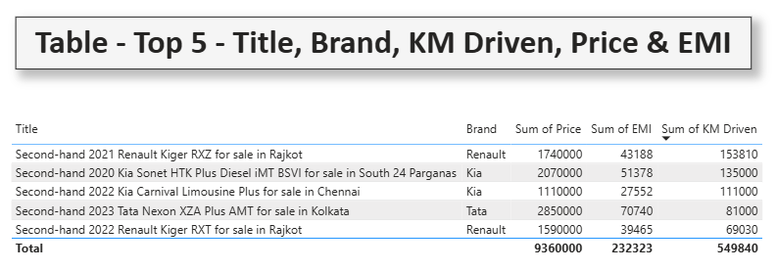
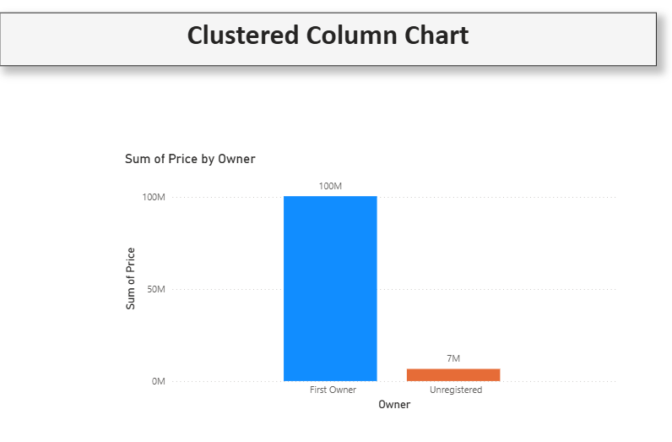

Insight:
Cars with higher mileage (>70,000 km) show reduced prices, except luxury brands which retain value better. First Owner cars consistently fetch higher resale prices compared to Second/Third Owner cars.
3. Interactivity & Filter:
- Added slicers (Brand, Fuel, Transmission, Price Band) for dynamic exploration.
- Applied filter actions so selecting a brand/fuel type updates all charts instantly.

4. Overall Insights from Power BI Dashboards:
- Petrol cars dominate the market in terms of count.
- Diesel cars command higher resale prices.
- Majority of used cars are First Owner and priced below ₹10 Lakh.
- Automatic cars, though fewer in count, are consistently priced higher than manual.
- Premium brands (BMW, Audi, Mercedes) have fewer listings but retain strong resale values.
4. Results & Findings:
From the analysis:
- Fuel Type Trends: Petrol cars dominated the listings, while Diesel cars showed slightly higher prices due to fuel efficiency.
- Ownership: Majority of cars were First Owner, but significant listings belonged to Second Owners too.
- Price Segmentation: Around 60–70% of cars fell under ₹10 Lakh, showing strong affordability demand in used markets.
- Most Driven Cars: Certain brands/models (like taxis and fleet cars) showed very high mileage but still retained value.
- Brand Insights: Brands like Maruti, Hyundai, and Tata appeared most frequently, indicating high resale availability. Premium brands like BMW, Audi, Mercedes were fewer but significantly higher priced.
- Challenges & Limitations:
During the project, several challenges were encountered:
    - Price Formats (Lakh/Crore)
    - Prices were listed in Lakh or Crore instead of full numeric values.
    - Solution: A custom format_price() function was created.
Code:
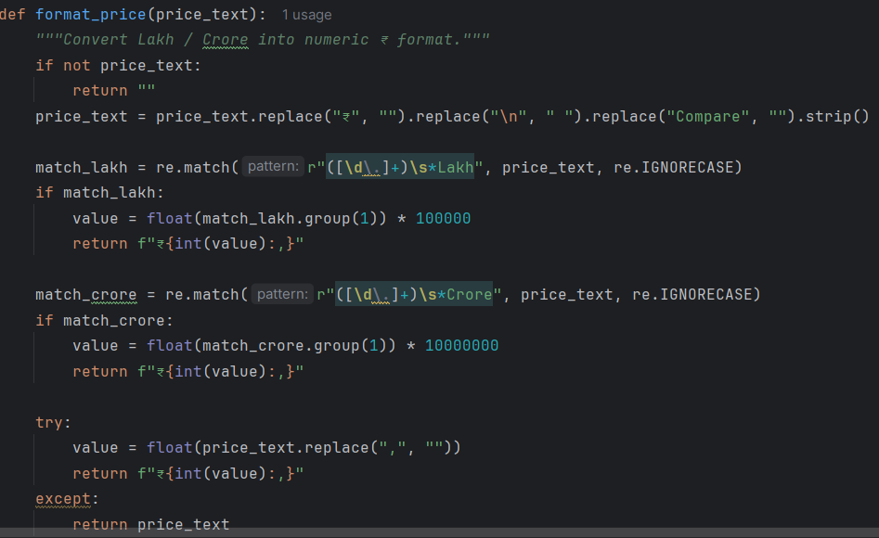
    - Missing & Inconsistent Data
    - Columns like Owner, EMI, Transmission were sometimes missing.
    - Solution: Replaced missing values with nil or 0 depending on type.
Code:
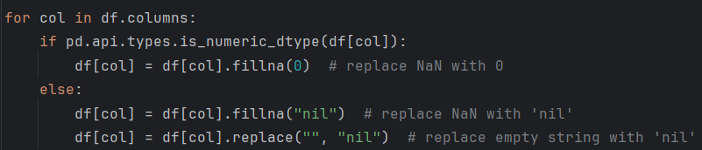

    - Time & Performance issues
    - Fetching detail pages for each car was slow.
    - Solution: Used ThreadPoolExecutor for parallel scraping.
Code:
- Conclusion:
The Used Cars Price Analysis project successfully demonstrated how data scraping, cleaning, and visualization techniques can be applied to extract meaningful insights from the used car market. By integrating Python for data collection and preprocessing with Power BI for interactive dashboards, the project created a complete analytics pipeline — from raw web data to actionable insights.
Key findings include:
- Price Variation by Fuel Type: Petrol cars dominate the listings in terms of count, while Diesel cars command higher resale prices due to fuel efficiency.
- Brand Influence: Mass-market brands like Maruti, Hyundai, and Tata show higher availability and affordability, whereas luxury brands such as BMW, Audi, and Mercedes retain significantly higher resale value despite lower volumes.
- Impact of Ownership: First Owner cars are priced higher and are more attractive to buyers, while Second/Third Owner cars are cheaper but less preferred.
- Transmission Trends: Manual cars dominate in number, but Automatic cars consistently hold a premium resale price.
- Mileage vs Price Relationship: Cars with higher kilometres driven generally show lower prices, except premium brands which retain value better.
- Affordability Insight: A majority of used cars fall under ₹10 Lakh, indicating strong demand in the mid-range affordability segment.
Overall, the project highlights the importance of data-driven decision making in the used car industry. Buyers can use these insights to identify fair prices and value-for-money cars, while sellers and dealers can better understand pricing dynamics to remain competitive.

